School-Based Vision Screening for Students in Public Schools
Updates to the Utah Administrative Rule R384-201 requires that Tier 2 vision screenings are completed for all students who are referred for special education evaluation when a Specific Learning Disability is suspected.

Procedures for Students Being Referred for Special Education (only required if Specific Learning Disability is being considered)
- The special education teacher will provide a copy of the Vision Symptoms Questionnaire to a general education teacher that has current knowledge about the student’s performance. For secondary schools, the English Language Arts teacher is recommended.
- The general education teacher will complete the Vision Symptoms Questionnaire and return the document to the special education teacher.
- The special education teacher will submit a completed copy of the Vision Symptoms Questionnaire to the school assigned district nurse via email.
- The district nurse will complete the Tier 2 Vision Screening and share the results with the special education teacher.
- If a vision referral is needed due to Tier 2 vision screening results, the district nurse will send the vision referral letter home to parents/guardians.
- The district nurse will be responsible for entering vision screening results into Skyward.

To access a copy of the Vision Screening Questionnaire
- On the Canyons District website, select departments and go to Responsive Services.
- From the Responsive Services webpage, select Support Areas and then select Nursing Services.
- Select the Vision Screening Questionnaire located at the bottom of the page in the Forms & Health Information section.
- Google Docs will ask if you would like to create a copy. Select yes.

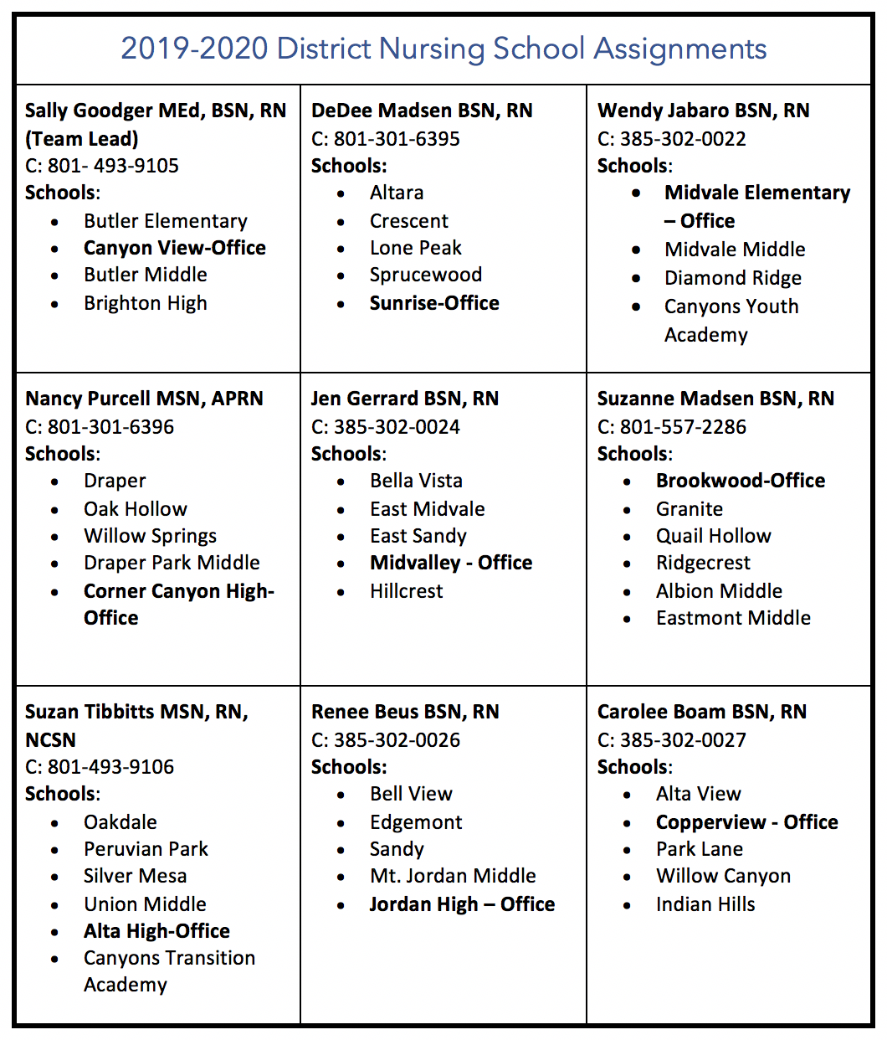

EXAMPLE Vision Symptoms Questionnaire
To download a copy of the questionnaire, go to the Nursing Services webpage found on the Responsive Services website.
Adapted from Utah Department of Health in accordance with UCA 53G-9-404
Student Name |  |  |  |  |  |  | Referral Date
School |  |  |  | Grade |  |  | Teacher
Name and Title of Person Completing the Form
Does the student wear glasses? |  | yes no
Teachers are required to complete this form if a student is being referred for special education services related to a specific learning disability. Parents may also complete this form if there is a vision concern.
If answer is ‘yes’ to any areas below, please provide you may be aware of in the comment section(s).
 |  |  |  |  |  | Yes |  | No | Additional Comments
As a teacher or parent are you concerned with this student’s vision?
Appearance Symptoms
Tilts head, squints, closes or covers one eye when reading
Gaze issues, eyes turn in or out, crossed eyes, eyes wander
Different size pupils or eyes
Watery eyes, eyes appear hazy or clouded
Complaints (Student Statements) Symptoms (please specify student complaints in comments section)
Words float, move, or jump around when reading
Complains of headaches, dizziness, or nausea when reading
Complains of itching, burning, or scratchy eyes
Complains of blurred or double vision, unusual sensitivity to light, or difficulty seeing
Behavior Symptoms
Loses place when reading
Skips over or leaves out small words when reading
Writes uphill or downhill; difficulty writing in a straight line
Has difficulty copying from the board
Avoids near work, such as reading and writing
Has difficulty lining up numbers when doing math
Has difficulty finishing assignments on time
Holds books too close; leans too close to a computer screen
Clumsy; bumps into things; knocks things over
Other Vision Concerns
Please return completed form to the assigned district nurse for tier 2 evaluation and possible referral to an eye care professional.
FOR SCHOOL NURSE USE ONLY
- Any parent or teacher concern and/or any ‘yes’ answers should be evaluated by the school nurse to determine if tier 2 screening or referral to an eye care professional is necessary.
- School nurse should use their professional nursing judgement in determining whether the student receives a tier 2 vision screening and/or is referred to an eye care professional, regardless of the answers.
Distance Vision Screened |  | pass fail
Near Vision Screened |  | pass fail
Eye Focusing or Tracking Screened |  | Yes No | If yes: pass fail
Convergence Screened |  | Yes No | If yes: pass fail
Referred to eye care professional |  | Yes No | Date
Additional Notes

School Nurse Name
School Nurse Signature |  |  |  | Date

